SRS
for
Advance licensing for Triplex printers

Software Requirements Specification

 | Name | Date
Written by: | Iris N &  Avi T | Last update: 17/8/2011
Approved by:
Version No: | Version 2

- Overview and Objectives
  - Objet Triplex platform will support the Advance Licensing (AL) capabilities.
  - Advance Licensing is a new SW feature which gives Objet the ability to control the machine licensing abilities by setting predefined values. This feature will allow us to control the legal materials, digital materials, Mixed parts and mixed tray per specific machine.
  - Offer the ability to implement different solutions according to customer needs based on SW licensing.
  - Such a solution will be comply by full SW licensing mechanism which will be able to control and monitor the system functionality; starting with a basic and specific solution (i.e. Dental) up to the superior capabilities of current Connex and future Triplex.
  - This solution will have the advantage of upgradability readiness, efficiency and flexibility by packages definitions.
  - The AL in the Embedded SW side, will focus on solution which has one main dimension:
Material Packages – mainly material offering according to the required solution.

- Advanced Licensing in light of the MRD Scope
The below appendix A represents the Advanced Licensing requirements in light of the Triplex MRD document.

Appendix A: Advanced Licensing Requirements for Triplex

- Triplex will have advanced licensing capabilities to allow different Material packages using the same HW platform.
- The licensing will be HASP protected [Avi: The communication between the EM and host is not secured. Due to that, we will close the loop by sending the Tray characteristics from the Objet Studio to the EM at the beginning of every printing, then the EM SW will verify that the Tray characteristics fits to the licensed package]
- Customers will be allowed to upgrade their HW with more advanced packages.
- In the long term, Triplex should have licensing capabilities covering the whole range of Objet high-end portfolio, from current Eden260V up to Triplex 500. E. g. Triplex 260 HW will allow licensing of Eden260V materials, Connex260 materials and Triplex 260 materials.
- Table A-1 below summarizes the required long-term advanced licensing capabilities of Triplex.
- For Triplex First release, only the Triplex Pro and Multi-Material packages are required.
- The naming of HW platforms and packages should be easily replaceable by using a name
Dictionary. In Table A-1 below, the names appearing in Italic are to be listed in the naming dictionary. [Avi: This part of the MRD require separate SRS since it is not related to the AL]
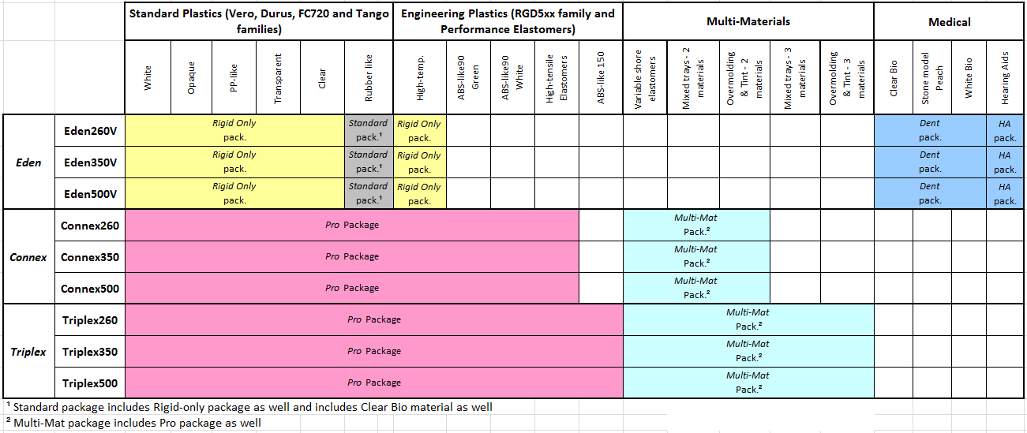
- High level definitions
  - The HASP dongle will hold a feature value/s that determines the licensed package/s.
  - Any package will have a unique value that determine it.
  - When the EM SW application is loaded, the SW will compare the data from the dongle and the data located in a new encrypted file that holds all packages definition. The SW will act according to clear definitions and will allow the user to use what’s in his licensing.
  - New encrypted file will contain a predefined material packages with the below data:
    - List of allowed parent Materials.
    - List of allowed DM’s combinations. (Both 2 and 3 materials DM’s)
    - Allowed mixed parts: Yes/ No
    - Allowed mixed tray: Yes/ No
* Any combination of the above is legal.
  - Predefined packages will be supplied by the marketing department.
  - Current dongle ‘pro’ type can support up to 35 features. That means maximum 35 packages can be loaded in a single HASP dongle.

- Implementation
  - A new file located under C:\machineID\Configs will be added to Triplex version 58.1 and up.
  - This file will hold all material packages definitions.
This file is already exist in the Objet systems (Alaris) and will hold all packages related to all Objet systems. This will require QA dedicated testing of the packages file content any time a new installation is prepared (Even if the package of the tested system was not changed).
  - The packages file extension is *.XML
  - The XML file will be encrypted with the Alladin HASP envelope protection.
  - The encrypted file name and extension will be: Packages.dat
  - The EM SW will check the availability of the Packages.dat file and will perform the required decoding only during the process of the EM SW bootup.
  - Max additive time allowed due to this new feature is 0.5 second during application boot up.
  - The table below describes the potential occurrences; Messages and SW behavior per each problem related to the AL package file:
potential occurrences. | SW behavior. | Message to the user. | Potential reason. | Comment
Packages.dat file doesn’t exist during application boot up. | EM application will not open. | TBD – T.W (#1) | file doesn’t exist
Packages.dat file deleted or corrupted during application runtime. | ----------------------- | ----------------------- | file doesn’t exist.  Corrupted  Packages.dat file. | Detection of the problem will occur during the next SW boot up.
Packages.dat exists but can’t be decoding (Due to any reason) by the SW during application boot up. | Application will not open. | TBD – T.W (#2) | Corrupted packages.dat file.
Packages.dat file exists, successfully decoded by the SW but the dongle does not contain any package definition. | Application will be open. All cartridges will be marked with “!“ sign (Illegal). And all the packages parameters will be off (e.g: Mixed tray = not licensed) | TBD – T.W (#3) | The dongle does not contain any package. | Rare situation might happen due to human mistake during the dongle burning process.

  - When the file Packages.dat exists, the application successfully decodes it and the dongle contain at least one package, the application will normally open.
  - An external utility to enable reading of the encrypted XML content in required as part of the AL implementation. (The tool won’t be placed as part of the installation files).
  - The tool will parse the encrypted data from the XML file and will open it in HTML/text file format (TBD by QA which format is preferred).
  - After the parsing process, the file will be unusable as a valid package.
  - The main purpose of this tool is for comparisons and validations for QA processes.
  - The available data related to the packages can be seen in the embedded application, under the Help→Hasp → Current data in a new Tab named: Licensed Packages. The Current HASP data will use the tab name: Plug Properties.
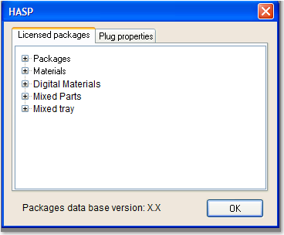
  - The XML file will be managed by versions. The version number will be seen under the Help→Hasp → Current data, on the left to the OK button as shown in the S.S above.
The version number will be shown as follow: “Packages data base version: X.X”
  - The data presented under each one of the fields will be as follows:
- Packages
Name of all licensed Packages (e.g.: Pro Pack; Multi Material Pack)
- Materials
Names of all Parent materials available in all licensed packages. (If the same material exists in more than one licensed package, it will be show in the list only one time). (e.g.: FullCure705; VeroWhite)
- Digital Materials
Names of all Digital materials available in all licensed packages. (If the same Digital material exists in more than one licensed package, it will be show in the list only one time). (e.g.: DM_8310_Grey25; DM_9860_Shore60)
- Overmolding
Licensed / Not Licensed
- Mixed Tray
Licensed / Not Licensed
  - Limitations of packages definitions:
- The “Mixed Parts” and “Mixed Tray” defines the license in a binary way (Yes/ No). Define those fields for specific material/s is not an option!

  - Package name won’t be mentioned in the main EM SW GUI.
  - The encrypted XML file will be added to the collect service data files - F2 function.
  - XML change is relevant in the following cases:
- New package/s definition
- Package/s renaming.
- The XML file can be replaced by new installation or by a standalone patch.
- When the patch is adding a new material/s or new DM/s – a patch is needed also on the studio side.
  - V2C file will be updated once the customer has bought a new license.
  - When inserting the dongle; the machine will recognize the valid packages and will reflect it in the application GUI and capabilities (Both Embedded and Objet Studio)
  - In case the user has inserted a cartridge of material which is not under the pack; a standard unsupported RF message will be shown and the GUI will show a standard behavior for unsupported case.
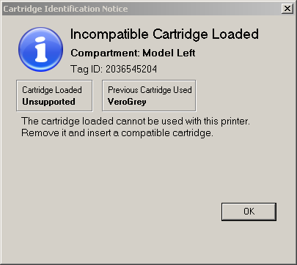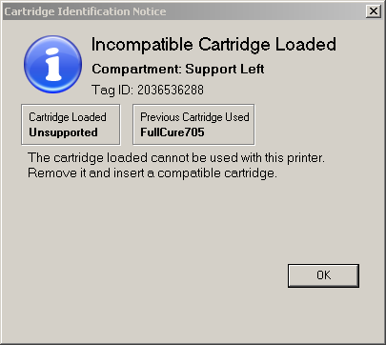

  - The packages data supplied by communication from the EM to the Objet Studio side, should reflect the capabilities of the package in the Objet Studio GUI and behavior ( Both in the Server and Client workstations)
  - Whenever a job is sent for printing from the Objet Studio, the Job Manager will send the current tray data characteristics to the EM. The EM will compare this data with the machine packages license. In a case the data is not fully compatible with the license, the printing will not start and an appropriate message will appear on the screen (T.W). This protection came to ensure no hacking occurs after the data was sent from the EM to the Objet Studio.
  - All new SW processes related to this implementation will not affect the system performance; time responses or any other system behavior. (If any change is observed, SW team will raise a flag as soon as possible)
  - Log file: The existing “follow up” log file will contain a list of all features exist under the license. All features will be written on the same line/s with “;” between them (“;+space”).
For example:
<15> 21/12/10 14:06:22 : HASP: Log in successful. Plug ID: 1232320548; packages: 281; 653; 589; 258; 254; 154; 458; 789; License type: perpetual
  - The below XML format is a sample of the Alaris system. This format is ok with the required adaptations required for the Triplex.

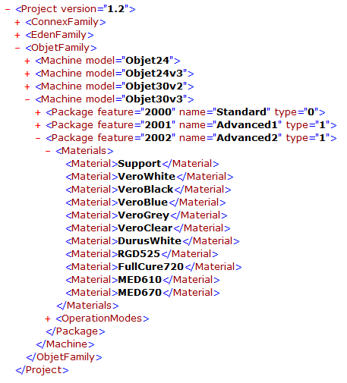

  - Any package in the XML file will contain a field that determines the “package type” as shown in the sample above. Three levels of “package type” required (Preferred 1,2,3, not “0”).
  - Changing the machine name in the GUI per the license package:
    - It is required to determine the machine name area in the GUI (e.g. Triplex) as a dynamic area that allows name change according to the higher level package available in the license.
    - This area will be predefined in the SW by its location and size (TBD the size but in general the maximum size available is preferred).
    - The XML file will contain all the BMP data in the same row of the package values (After the “package type” field).
    - The BMP should not be accessible for any change by unauthorized person and therefore it should be encrypted (or protected by other method suggested by the SW team).
    - The BMP’s should not be part of the main code since it should be part of future XMl’s upgrades via SW patches.
    - The BMP attached to the higher package will be loaded to this specific area and will be presented in the EM application GUI.
    - In a case there are no BMP’s attached to any of the legal packages, the application will use the default GUI and machine naming.

